**Gone bananas**-the app for a healthy lifestyle (ages 6-11)

## **Created by Jessica Barnett, Joshua Wilson, Anna Bartsch, Alexa Piatkiewizz**

# Team 11- App description

Our app is created to help children ages 6-11 to have fun learning about a healthy lifestyle and living a healthy lifestyle including the right diet and physical activity. It is supposed to be a fun way to motivate children to be physically active and learn about a healthy nutrition as well. Depending on the player’s choice the character that represents them within the app will change and become stronger or weaker. Further, the more points get unlocked, the more gear for the character will unlock.

The app gives the children the option of choosing either a girl or a boy avatar to start their health journey. Once the character is selected, the child can begin to play the games and collect points. The children will be led to a Main Menu in which they have the option to go to a Trivia quiz to test their knowledge about nutrition, building a plate, viewing the recipe of the day, tracking their results of the pedometer or playing a game separating good foods from bad foods.

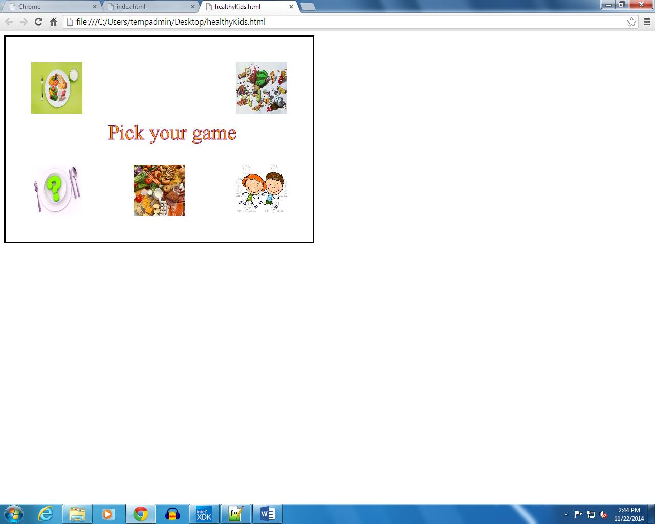

In the current state the children can only select the pedometer and the food game from the main menu. When selecting either of those two windows, the children will hear C3PO welcoming them to the application they chose. Within the pedometer app, the children can track the amount of steps/miles they walked that day and the corresponding speeds. As they walk, run or move more, they can see their avatar moving along the screen on the path.

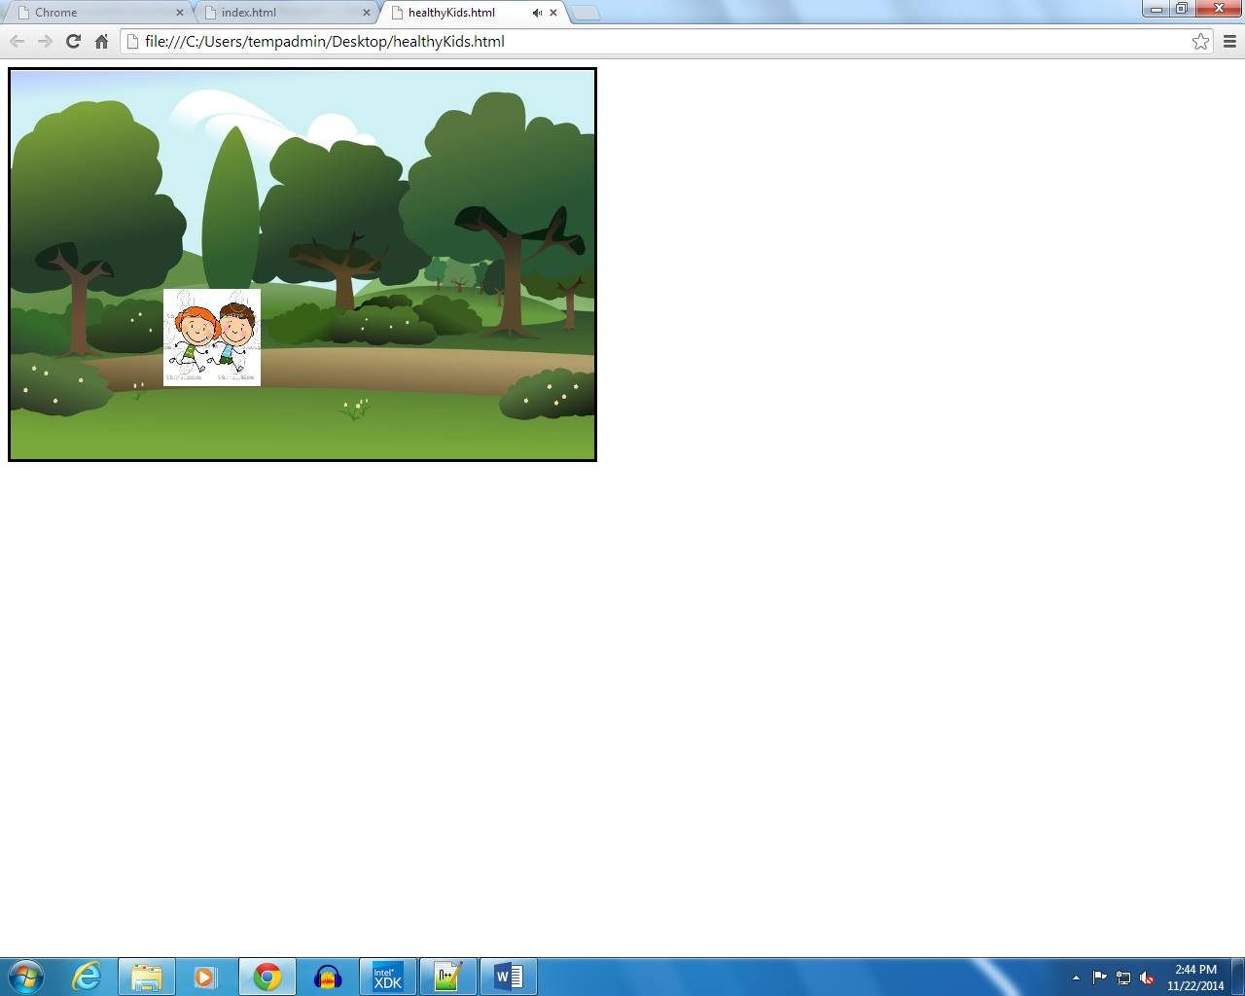

\When selecting the food game app, they have to click (on computer) or tab (on phone and tablets) on the healthy foods and get points. When clicking or selecting the bad foods, they will get docked points. The speed at which the foods are falling increases after the player receives 10 points, 20 points and so on.

